Dialogue Scripting Tool

Sprint 2: Design

Team 6

Shutong Ji
Swarna Sweth
Aryan Navin
Leyan Huang
Jay Stadelman

Software Engineering I
CS-GY 6063 - I2
Fall 2026

Instructor: Raz Saremi
Date: 2026.10.20

AI - Disclosure:
AI was used in the process of making this document.
- Claude Sonnet 5.5:
  - Was used for meeting notes
  - It was used as a research aid for the Data design records, to find reference material on storing Markdown and JSON, and how Django handles database transactions.
- ChatGPT 5.6 SOL
  - Used for research assistance into architecture design

Sprint Goal - Visualizing all elements of the project. Produce the design document for your team project. Use UML where it helps, and explain why the team chose to use or not use UML for each part of the design.

1 Architecture Overview
Author: Jay Stadelman
Reviewer: Aryan Navin

Project note – The architecture is subject to change due to technical gaps. We have never created a project like this and thus might not have a complete understanding of what is required and will work.
The system uses a client-server, layered architecture. The client is a web application running in the user’s browser where Narrative Designers and Reviewers interact with the Markdown and the node-based GUI. Requests from the client are sent to the Django server, using HTTPS, which separates responsibilities across 5 different services (authentication and permissions, project services, dialogue parsing/conversion, GitHub integration, and database access). The Django server sends the structured project data to be stored in a PostgreSQL database and the authoritative markdown file in a Github repository.

General structure:
- Web Application:
  - The user interface for editing the Markdown and node GUI
- Django Server:
  - Authentication & Permissions – verifies user identity and determines which project actions each role may perform.
  - Project Services – coordinates project operations selected on the web application such as open, save, delete, export, and sync.
  - Parser/Converter – Converts between Markdown and the node-graph JSON representation and validates the files
  - GitHub Services – Communicates with the GitHub API to read and save Markdown files and maintain their commit history.
  - Database Services (Django Object-Relational Mapper) – Reads and writes project data for the database (project metadata, user authentication information)
- GitHub (repository)
  - Stores the “truth” Markdown file and its version history
- Neon (or another) PostgreSQL database
  - Store structured application and project data
The architectural style we chose for this project is a client server + layered architecture.
- The client is the web app running in the user's browser.
- The server is the Django application, which handles authentication & permissions, project services, parsing/conversion, and access to external storage.
At this time we feel this best fits our project because:
- The application must be web-based, so the client server architecture naturally separates the browser UI from the server-side processing and storage.
- A layered design keeps authentication, project logic, parsing, GitHub access, and database access separate which will be easier to test and maintain.

Deployment View:
- Client (web app) – The user access the application through a web browser
  - The browser runs the user interface for the markdown editor and node-base GUI
- Application server (Django server) – Will be hosted on a cloud platform such as Vercel or AWS (whichever is cheaper).
  - It handles authentication, project logic, parsing/conversion, and communication with storage services.
- Database (whichever is cheapest) – Will store users, teams, project metadata, permissions, and synchronized/version history
- External Service (GitHub) – Stores the authoritative markdown files and commit history
  - Django servicer communities with Github via the GitHub API
We will also need a few environments for this project:
- Development – Each team member (team 6) runs the Django application locally while developing and testing
  - We will use the GitFlow style of feature branching
- Staging/Testing – A shared cloud deployment to test integrated feature
- Production – The final deployed version which is hosted online and connected to the production database and “main” GitHub repository

General Structure:
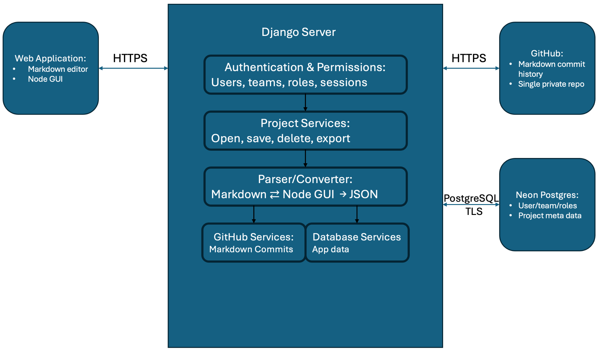

Proposed flow for parsing the Markdown file into the Node GUI:

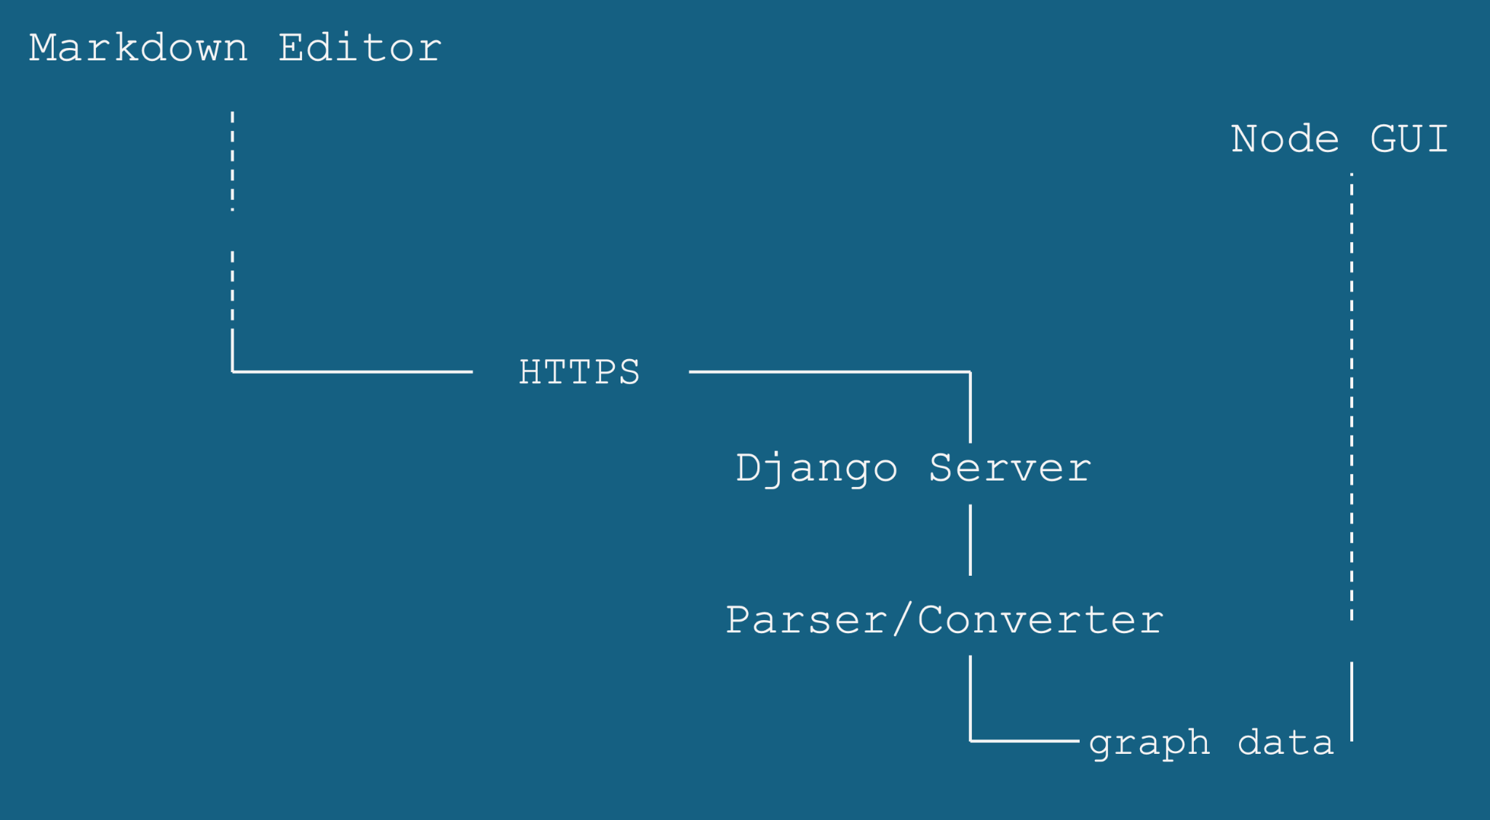

2 Modeling Choices (UML Decision)
Author: Aryan Navin
Reviewer: Shutong Ji
View | Decision | Where | Reason
Use Case | Skipped | Sprint 1 backlog | We skipped the Use Case diagram because our 13 MVP stories already explicitly define the person, goal, and given/when/then criteria. A diagram would just repeat this documented list without adding new architectural value.
Class/Domain Model | UML Class Diagrams and ER Diagram | - DD-1 dialogue structure  - DD-3 editing session  - DD-4 validation and export  - DD-2 stored data | We chose UML class diagrams and an ER diagram. UML Class diagrams are well suited for data that has no table: dialogue objects parsed from Markdown, validation and export results, and the browser editing session, while the ER diagram defines the six database tables with their keys, required columns, and foreign keys, which the backend needs to build the schema.
Sequence | UML Sequence Diagrams | - Flow 1 (Load/Parse)  - Flow 2 (Export) | We chose sequence diagrams to show the time ordered API interactions between the browser, Django and the Lark parser, and Postgres database. This format specifically allows us to map out exactly where 401, 403, and 404 error responses occur during complex permission paths.
State Machine | UML State Machine Diagram | - End Of Section 5 (State Machine Diagram) | We used a UML State Machine diagram because the sync_status in the browser has a specific lifecycle driven by user actions. It clearly maps the transitions between InSync, MarkdownChanged, GraphChanged, and BothChanged during bidirectional editing.
Activity | UML Activity Diagram | - Section 5 (US-36 Delete/Undo) | We chose an Activity Diagram to model the delete and undo functionality because it involves a procedural flowchart of conditional actions (e.g., checking if external nodes refer to the selection, popping changes from the UndoHistory stack). This format perfectly captures that branching execution flow.
Component or Deployment | Custom Architecture Diagram | - Architecture Overview | We decided to use a custom architecture diagram instead of strict UML to map out our deployment. A custom diagram was much more effective at clearly showing where each part runs and what it talks to. So we have the hosted Django server, Neon Postgres, and the GitHub API, with the HTTPS boundary between client and server. One diagram has both the component responsibilities and the hosting view, so two separate UML diagrams would repeat the same boxes.
Activity | UML activity diagram | - Architecture Overview | Show the bidirectional flow of data between the Markdown and Node GUI. It shows steps required to convert the Markdown into the Node GUI and the Node GUI into the Markdown.

3 Data Design
Author: Leyan Huang
Reviewer: Swarna Sweth

This section defines the data used to access, edit, save, check, and export a dialogue Project. Markdown is the authoritative dialogue content. Each Project's Markdown is stored as a file in a private GitHub repository, and the other project data is stored in Neon Postgres.

3.1 Data Model Overview
3.1.1 Data ownership
One Project contains one Markdown source and is saved as one unit. A Team owns the Project, and its members can access it through the Django server.
Category | Data | Lifetime and purpose
Stored in GitHub | One Markdown file per Project | The authoritative dialogue source. The file's commit history records each saved version.
Stored in Postgres | User, Team, TeamMembership, Project, NodePosition, Comment | Preserved across browser sessions. Project records which commit holds its saved Markdown. Positions and comments hold editor information.
Derived from a source snapshot | Node, DialogueLine, Choice, Jump, Variable, Effect, ValidationIssue, Export | Built for editing, checking, or export. Each result belongs to the particular input that produced it.
Browser session | EditingSession, UndoHistory | Holds working Markdown, working graph, selection, synchronization state, and reversible changes while the Project is open.
The node graph combines parsed dialogue with saved NodePositions. Choices and Jumps supply its connections. Comments are loaded separately and attached by Node ID. Displaying the graph therefore does not require another stored copy of its dialogue content.
Playtesting, translation catalogs, line hashes, and node groups are outside this MVP model. Access depends on TeamMembership and Comment authorship, not on user personas.
3.1.2 Storage responsibilities
Django owns authorization, parsing, validation, and persistence. The browser sends project requests to Django.
Location | Data | Written by
Neon Postgres | The six stored tables in Figure DD-2, including each Project's revision and head_commit_sha | Django. A Save writes its tables in one transaction (section 3.3.2).
Private GitHub repository | One Markdown file per Project, with one commit for each Save that changes it | Django, during Save (section 3.1.3).
Browser | EditingSession and UndoHistory | The editor. Working edits persist only through Save.
3.1.3 Save order and history
A Save that changes the Markdown first commits the new file to the private GitHub repository at projects/<project_id>.md. Django then writes the positions, the new revision, and the commit's SHA as head_commit_sha in one PostgreSQL transaction. A Save that changes only positions makes no commit. Each commit message records the Project, the new revision, and the User who saved it.
head_commit_sha determines which version of the file belongs to the Project. If the database write fails after a GitHub commit, the Project still points to the previous commit and reopens in its last saved state; the unused commit remains in the repository history. Django sends repository writes one at a time, because concurrent writes to one repository conflict.
The commit history of a Project's file is its save history. Positions and Comments are not part of that history. Changes made directly in the repository are not imported, and the next Save replaces the file.

3.2 Entities and Key Attributes
The tables describe the logical fields used by the application. PK means primary key, FK means foreign key. In the Unique column, yes marks a unique field, with <field> marks a field that is unique together with that field, and no marks a field without a uniqueness rule. Fields are required unless marked optional. Identifier fields use the same type as the key they reference. Figures DD-1, DD-3, and DD-4 use UML class notation: «stored», «derived», and «session» mark data kept in Postgres, data built from a Markdown snapshot, and data held only in the browser. Figure DD-2 uses Crow's Foot notation: ● marks a required column, and columns marked with the same AKn are unique together. Header colors group related entities across the figures.
3.2.1 User, Team, and TeamMembership
US-31, US-13; Permissions & Privacy
Entity | Attribute | Type | Unique | Rule
User | id | identifier | Primary Key
User | email | string | yes | Address used to sign in.
User | display_name | string | no | Name shown as the author of Comments.
Team | id | identifier | PK
Team | name | string | no | Name shown on the team dashboard.
TeamMembership | id | identifier | PK
TeamMembership | team_id | identifier | with user_id | Foreign Key to Team
TeamMembership | user_id | identifier | with team_id | Foreign Key to User
A TeamMembership records who belongs to a Project's Team. Django checks membership on project requests, including requests sent directly to the API. Comment editing and deletion also require the requesting User to be the author. Authentication supplies login credentials and authentication sessions; EditingSession below describes the open editor.
3.2.2 Project
US-31, US-37, US-35; Data Integrity
Attribute | Type | Unique | Rule
id | identifier | PK
team_id | identifier | no | FK to Team. Multiple Projects may belong to the same Team.
name | string | no | Name shown on the team dashboard.
github_path | string | yes | Path of the Project's Markdown file in the repository: projects/<project_id>.md.
head_commit_sha | string, optional | no | Commit that holds the saved Markdown. Empty until the first Save that writes Markdown; until then the source is empty.
revision | positive integer | no | Starts at 1; increases once for each successful project save.
revision identifies the saved state used for conflict detection. A client submits its base_revision with a save request. The server accepts the save only if it still matches the stored revision. This integer token implements the version check required by US-31 and the Data Integrity NFR.
A Project revision covers its Markdown and saved positions. A successful Save that changes the Markdown also creates one GitHub commit and records it in head_commit_sha. Comment writes have a separate transaction and do not increment Project.revision or create a commit. Deleting a Project removes its Postgres rows and commits the removal of its file; earlier commits remain in the repository history.
3.2.3 NodePosition
US-37, US-29
Attribute | Type | Unique | Rule
id | identifier | PK
project_id | identifier | with node_id | FK to Project.
node_id | string | with project_id | Identifies a Node in the Project's Markdown source.
x | number | no | Finite horizontal canvas coordinate.
y | number | no | Finite vertical canvas coordinate.
A Node has at most one saved position. A Node without one receives a default layout when displayed. Moving a Node changes its position without changing dialogue, destinations, conditions, or Effects. Positions are stored with the cloud Project, separately from Markdown syntax.
There is no stored Node table, so node_id is an application-level reference rather than a database FK. When the candidate Markdown parses and its Node IDs are unique, Django checks the positions against it during Save and removes positions for deleted Nodes in the same database transaction that records the new commit. Otherwise, the saved positions stay unchanged.
3.2.4 Comment
US-13
Attribute | Type | Unique | Rule
id | identifier | PK
project_id | identifier | no | FK to Project.
node_id | string | no | Identifies the Node to which the Comment belongs.
author_id | identifier | no | FK to User; assigned from the authenticated User and never changed.
body | text | no | Nonblank review note.
created_at | datetime | no | Assigned when the Comment is created.
edited_at | datetime, optional | no | Assigned when its author changes the body.

Comments are shared review data, separate from dialogue content. Creating, editing, or deleting a Comment leaves the Markdown file unchanged. Comment changes are saved independently and are excluded from graph Undo and the game-facing JSON export.
Like NodePosition, Comment uses node_id as an application-level reference within its Project. A new Comment must target a Node in the current saved source. A newly created Node must therefore be saved before it receives shared Comments. When a Save removes a Node from Markdown that parses with unique Node IDs, that Node's Comments are deleted in the same database transaction that records the new commit. Otherwise, existing Comments stay unchanged.
3.2.5 Derived dialogue data
US-01, US-29, US-32, US-34, US-35, US-36, US-25
Parsing a SourceSnapshot produces the following objects. The snapshot contains one Project's exact saved or working Markdown. Object identities and source locations apply to that input.
Entity | Key attributes | Meaning and constraints
Node | node_id: string; source_location: SourceLocation | Nonblank ID, unique within the Project. SourceLocation maps the Node back to the Markdown that was parsed.
DialogueLine | text: text; content_index: integer | One dialogue block and its position in the Node's ordered content.
Choice | text: text; target_node_id: string; condition: Condition, optional | A player option. A valid export requires its text and a target that resolves within the Project.
Jump | target_node_id: string; condition: Condition, optional; content_index: integer | An automatic redirection at a particular point in the Node's content. No condition means an unconditional Jump.
Variable | name: string; type: type name; scope: scope reference; initial_value: typed value | A declaration. References retain its name and scope; initial_value must match type.
Effect | variable_name: string; variable_scope: scope reference; operation: operation name; value: typed value | One instruction attached to a Choice. Its target must resolve to a declared Variable, and its operation and value must be valid for that type.
SourceLocation records a span in a particular Markdown snapshot. It is not a permanent Node identity. Condition holds the dialogue expression controlling a Choice or Jump. A Connection is derived from a Choice or Jump and its target; its kind lets the graph distinguish player choices from automatic jumps.
DialogueLines and Jumps share one ordered sequence. Choices retain their order within a Node, and Effects retain their order within a Choice. The JSON representation preserves these orders with arrays or explicit ordering fields. US-34 requires Boolean and integer values and distinguishes global and local declarations. A global variable resolves throughout the Project.
Effects describe changes for a game to apply. Exporting “subtract 5 from global coins” preserves the declared initial value of 10 and attaches the subtraction only to the relevant Choice. Export does not execute the Effect.
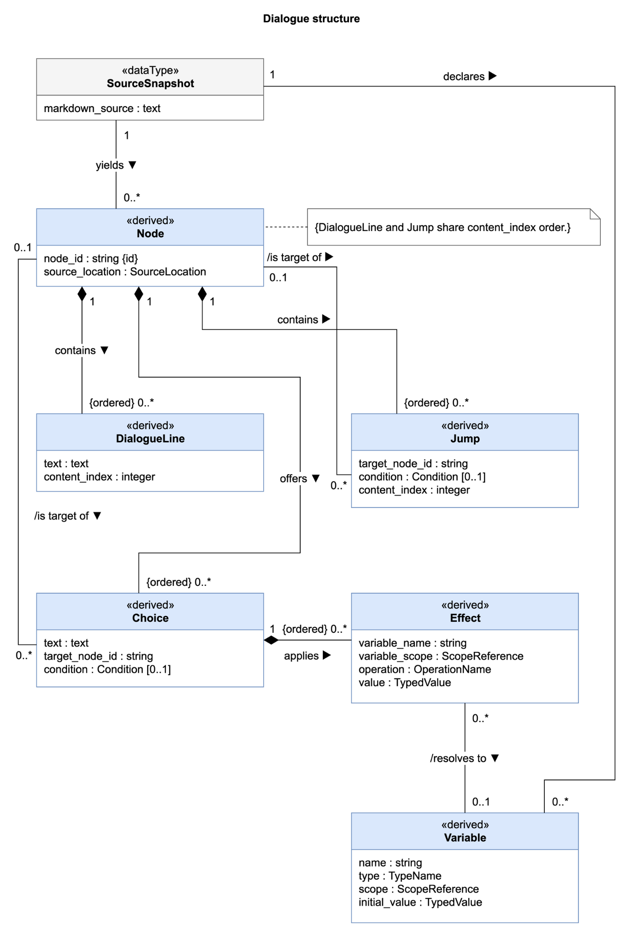
Figure DD-1. Dialogue structure
3.2.6 ValidationIssue and Export
US-01, US-02, US-17, US-25, US-32, US-34
Object | Data | Meaning
ValidationIssue | message; severity; detected_at | Description, a Severity value (error or warning), and timestamp.
ValidationIssue | input snapshot reference | Identifies the SourceSnapshot or captured NodeGraph that was checked. Results become outdated when that input changes.
ValidationIssue | node_id; source_location; field; affected object reference | Relevant identifiers and failure location, when available. A dead-end result includes its Node ID; a schema error identifies its failed field.
Export | schema_version; nodes; variables | The JSON AST produced after successful validation. Nodes include IDs, ordered content, Choices, Jumps, conditions, Effects, and destinations.

The export format includes an explicit schema_version, which changes when the JSON contract changes.
Export uses a SourceSnapshot of the Project's saved Markdown. When the working copy has unsaved changes, the editor asks the user to save first, so the JSON matches what the user sees. Validation and JSON generation use that same snapshot. A successful export contains narrative data and omits Comments, NodePositions, membership information, and UndoHistory.
JSON is returned as a download after validation. An export failure reports its issues without creating or replacing the output file. Export does not save the Project or require a stored JSON copy.
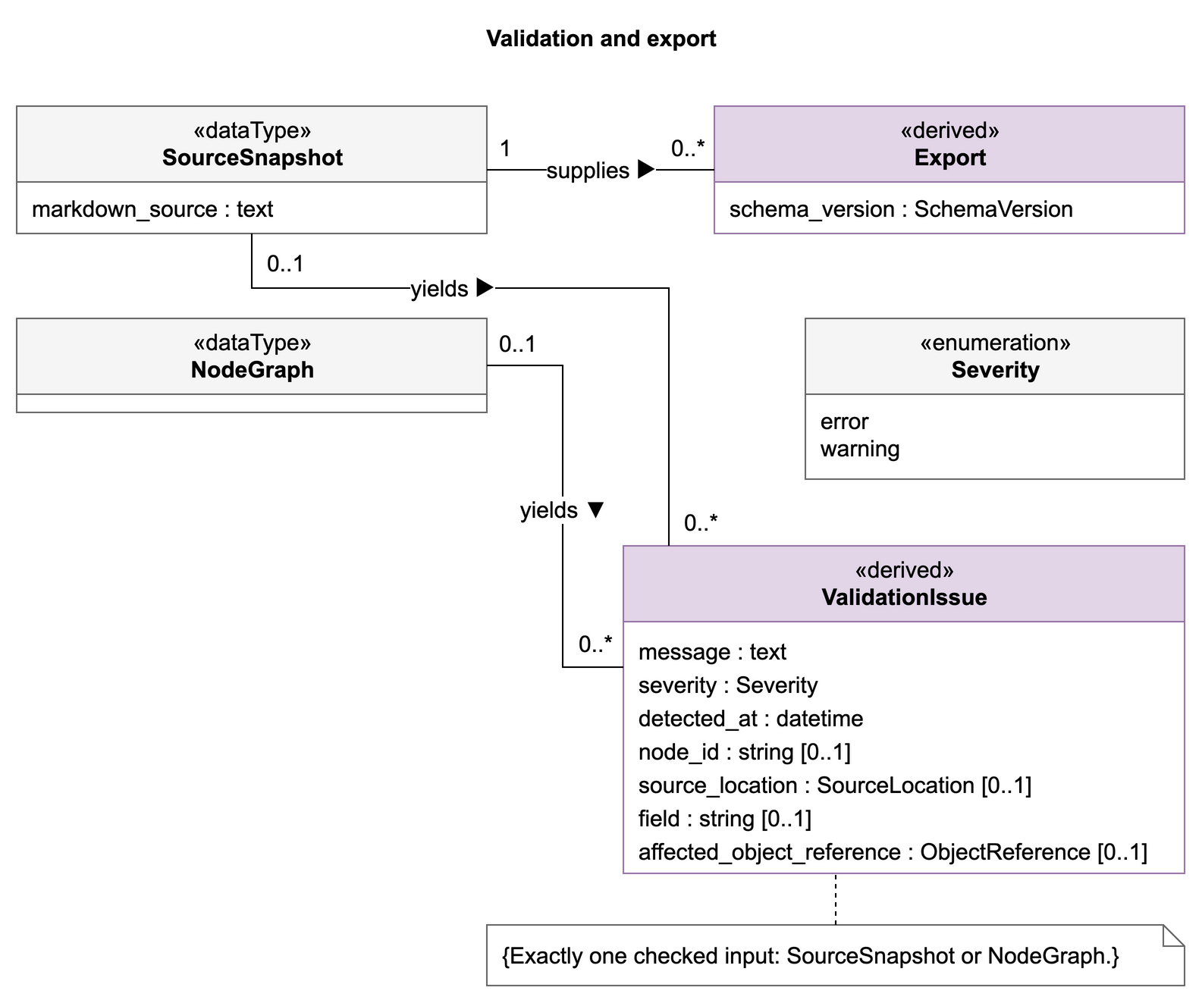
Figure DD-4. Validation and export
3.2.7 EditingSession and UndoHistory
US-35, US-37, US-36, US-20
Data | Meaning
user_id, project_id | Identify whose working copy is open.
working_markdown, working_graph | The editable Markdown and NodeGraph views; they may temporarily differ.
working_positions | Current canvas positions, including movements not yet saved.
base_revision | Revision loaded from the server or returned by the last successful Save.
sync baseline | Content represented by both views after the last successful Load or Sync.
sync_status | A SyncStatus value: InSync, GraphChanged, MarkdownChanged, or BothChanged, measured against the sync baseline. Layout-only movement does not change this content status.
selection | Selected Node IDs, including a multiple-Node deletion selection.
has_unsaved_changes | Whether project content or positions differ from the last saved state.
UndoHistory | Ordered reversible changes for this editing session; empty on opening a Project.
Sync status and save status are independent. A session can be InSync while still containing unsaved work. A successful Save updates base_revision; it does not mark later edits as saved. Multiple users or browser tabs have separate working copies and Undo histories.
Undo reverses changes one at a time in reverse order, restoring deleted content, connections, and positions; with nothing left to undo it changes nothing, and after a Save it changes only the working copy until the next Save.
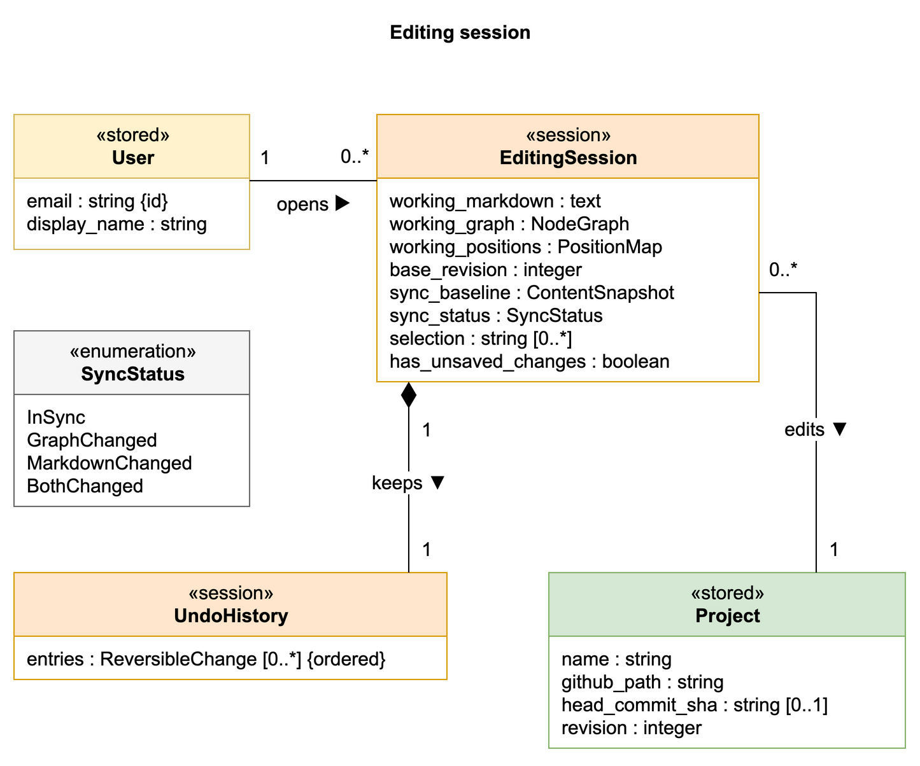
Figure DD-3. Editing session

3.3 Relationships and Constraints
3.3.1 Relationships
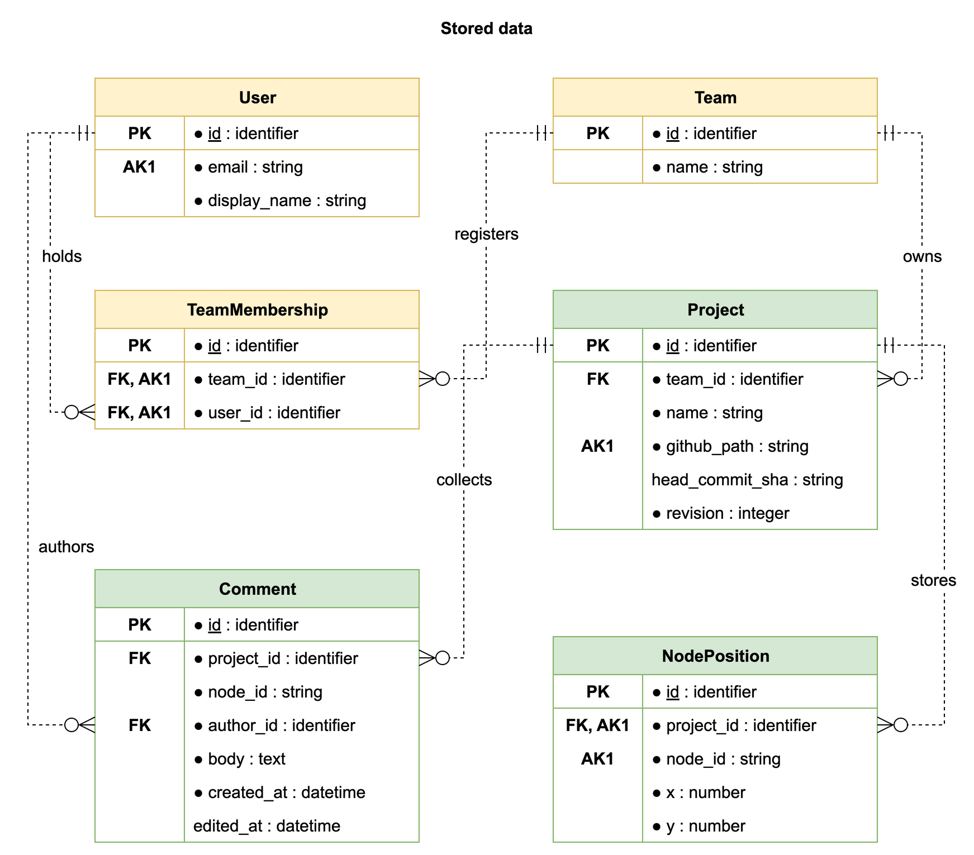
Figure DD-2. Stored data
Relationship | Multiplicity | Constraint
User / Team – TeamMembership | Each User or Team has 0..* memberships; each membership has one of each | team_id and user_id are unique together; both FK references must exist.
Team – Project | 1 : 0..* | Each Project belongs to exactly one Team.
Project – NodePosition / Comment | 1 : 0..* each | Every stored position or Comment belongs to one Project.
User – Comment | 1 : 0..* | Every Comment has exactly one author.
SourceSnapshot – Node / Variable | 1 : 0..* each | An empty new Project has no parsed Nodes or Variables.
Node – DialogueLine / Choice / Jump | 1 : 0..* each | Each child belongs to one Node. Removing a Choice does not remove its destination Node.
Choice / Jump – target Node | Many references to one target | A valid reference resolves to one Node in the same Project. A draft can contain an unresolved reference.
Choice – Effect – Variable | A Choice has 0..* Effects; each valid Effect resolves one Variable | Resolution uses the declaration's scope and name.
EditingSession – User / Project / UndoHistory | One User, one Project, one history per session | Session data is separate from persisted project data.
3.3.2 Save consistency and access
A Save checks authentication, TeamMembership, the submitted revision, and the candidate Markdown. Empty Markdown is valid for a new workspace. Save keeps the Markdown even when it has errors: syntax errors, duplicate Node IDs, missing destinations, and type errors are returned as diagnostics and block the operations that need valid input, as listed below. Save updates positions and removes metadata for deleted Nodes only when the Markdown parses and its Node IDs are unique; otherwise, existing positions and Comments are preserved. If position changes are not saved, the response reports this and the editor keeps those changes marked as unsaved.
Django locks the Project row for the whole Save, so the revision check, the GitHub commit, and the database write cannot interleave with another Save of the same Project. Positions, revision, and head_commit_sha are written in one PostgreSQL transaction after the GitHub commit succeeds.
Result | Stored state
Successful Save | A changed Markdown file is committed to GitHub; positions, the new revision, and head_commit_sha then commit together.
Outdated base_revision | Return 409 before any GitHub write; stored data remains unchanged.
Malformed request | Return 400 before any GitHub write; nothing is stored.
Markdown with errors | Committed like any other change; the response lists the diagnostics. If the Markdown does not parse or has duplicate Node IDs, positions and Comments stay unchanged, and the response says which position changes were not saved.
GitHub write failure | The Save fails and Postgres is unchanged. The browser retains the working edits.
Database failure after the GitHub commit | head_commit_sha still names the previous commit, so the Project reopens in its last saved state. The browser retains the working edits.
Unauthenticated request | Return 401 without exposing project data.
Authenticated nonmember | Return 403 without exposing project data.
Reopening a Project reads its positions, revision, and head_commit_sha from Postgres, then reads the Markdown at that commit from GitHub and builds the graph from it. Unresolved destinations in the saved source appear as broken links and do not block Open. If the saved Markdown does not parse or has duplicate Node IDs, Open shows the Markdown and its diagnostics without a graph until it is fixed. If GitHub is unavailable, the Project cannot be opened until GitHub is available again. Comment operations use current membership and authorship checks.
3.3.3 Synchronization and valid states
Saving from the graph first converts graph edits to Markdown, using the same conversion and conflict rules as manual graph-to-Markdown Sync. Errors in the result are reported but do not block Save. If both views changed, the user chooses which content to keep before Save proceeds. Markdown edits reach the graph through manual Markdown-to-graph Sync.
Operation | Data requirement and result
Edit | Working views may differ and contain unfinished content. Source locations and validation results apply only to the input from which they were derived.
Sync | The selected input must parse, have unique Node IDs, and contain resolving Choice and Jump targets. Replace the destination view only after all checks succeed. Cancel or failure preserves both existing views.
Save | Pending graph edits are first converted to Markdown, as in graph-to-Markdown Sync. The Markdown is saved even if it has errors; parse errors, duplicate Node IDs, and missing destinations are returned as diagnostics. Positions are checked and updated only when the Markdown parses with unique Node IDs. Save does not establish that the Project is ready to export.
Continuity check | Identify dead-end choices and their Node IDs; detect loops without traversing indefinitely. A Node with no outgoing transition can be a normal ending.
Export | Require valid syntax, unique Node IDs, resolving targets and Variables, compatible types and operations, required fields, and a valid JSON schema.
Loops are reported as warnings because a loop can be an intentional narrative path. A missing target is an error. A successful continuity check with no issues reports a clean result.
Markdown, dialogue text, and conditions are treated as data. Displaying or parsing them must not execute embedded HTML, JavaScript, or Python. Conditions and Effects use the dialogue language's supported expressions and operations.
3.3.4 Node identity and deletion
Text edits and layout movements preserve node_id. Renaming an ID requires updating its narrative references, NodePosition, and Comments together. Metadata must not become attached to an unrelated Node that reuses an old ID.
Deleting a selection preserves Nodes outside that selection. If another Node refers to the selection, the operation identifies the affected Nodes and asks for confirmation or cancellation. Undo retains the deleted content and affected references. Removing a destination does not implicitly delete the Nodes that referred to it.

4 Interface Design
Author: Shutong Ji
Reviewer: Leyan Huang

4.1 API Endpoints

1. User Login

POST /api/v1/auth/login
- Supported User Stories: US-31
- Allowed Callers: Unauthenticated Users
- Inputs:
  - Header: Content-Type: application/json
  - Request Body:
JSON
{
"email": "designer@email.com",
"password": "somepassword"
}

- Outputs:
  - 200 OK:
JSON
{
"token": "jwt_token_string",
"user": {
"id": "u123",
"name": "designerA",
"email": "designer@email.com"
}
}

- Error Responses:
  - 400 Bad Request: Missing required email or password.
  - 401 Unauthorized: Invalid credentials or unverified account.

2. Create Project

POST /api/v1/projects
- Supported User Stories: US-37
- Allowed Callers: Authenticated Users
- Inputs:
  - Header: Authorization: Bearer <jwt_token>
  - Request Body:
JSON
{
"name": "Act 1 Dialogue",
"team_id": "team_6"
}

- Outputs:
  - 201 Created:
JSON
{
"project_id": "p987",
"name": "Act 1 Dialogue",
"markdown_source": "",
"revision": 1,
"created_at": "2026-10-07T10:00:00Z"
}

- Error Responses:
  - 401 Unauthorized: Missing or invalid JWT authentication token.
  - 403 Forbidden: User is not a member of the team_id.
  - 422 Unprocessable Entity: Invalid project name format or empty project title.

3. Fetch Project

GET /api/v1/projects/{project_id}
- Supported User Stories: US-31, US-37, US-01
- Allowed Callers: Authenticated Team Members of the Project
- Inputs:
  - Header: Authorization: Bearer <jwt_token>
  - Path Parameter: project_id (string)
- Outputs:
  - 200 OK:
JSON
{
"project_id": "p987",
"team_id": "team_6",
"name": "Act 1 Dialogue",
"markdown_source": "# Node_Merchant_Greeting\n...",
"revision": 3,
"layout_data": {
"nodes": [{ "id": "Node_Merchant_Greeting", "position": { "x": 100, "y": 200 } }]
}
"comments": [
{
"comment_id": "c001",
"node_id": "Node_Greeting",
"author_id": "user123",
"body": "Check the mood of the dialogue.",
"created_at": "2026-10-14T01:15:00Z"
}
]
}

- Error Responses:
  - 401 Unauthorized: Unauthenticated request.
  - 403 Forbidden: User is authenticated but is not a member of the project's assigned team.
  - 404 Not Found: project_id does not exist.
  - 503 Service Unavailable: Github API service is unreachable.

4. Export Compiled JSON

GET /api/v1/projects/{project_id}/export
- Supported User Stories: US-01, US-17, US-25, US-34
- Allowed Callers: Authenticated Team Members of the Project
- Inputs:
  - Header: Authorization: Bearer <jwt_token>
  - Path Parameter: project_id (string)
- Outputs:
  - 200 OK:
JSON
{
"project_id": "p123",
"schema_version": "1.0.0",
"variables": [
{
"name": "visited_merchant",
"type": "boolean",
"scope": "global",
"initial_value": false
}
],
"compiled_json": {
"nodes": [
{
"id": "Node_Merchant_Greeting",
"metadata": { "category": "shop", "color": "blue" },
"sequence": [
{
"type": "dialogue",
"line_id": "dlg_mrc_001",
"speaker": "Merchant",
"text": "Ah, welcome back, traveler!"
},
{
"type": "mutation",
"op": "set",
"var": "visited_merchant",
"value": true
}
]
}
]
}
}

- Error Responses:
  - 401 Unauthorized: Missing or invalid authentication token.
  - 403 Forbidden: User lacks team permission to export project assets.
  - 422 Unprocessable Entity: AST validation failed before export.

5. Delete Project

DELETE /api/v1/projects/{project_id}
- Supported User Stories: US-37
- Allowed Callers: Authenticated Team Member of the Project
- Inputs:
  - Header: Authorization: Bearer <jwt_token>
  - Path Parameter: project_id (string)
- Outputs:
  - 200 OK:
JSON
{
"message": "Project p123 successfully deleted."
}

- Error Responses:
  - 401 Unauthorized: Missing authentication.
  - 403 Forbidden: User is authenticated but is not a member of the project's assigned team.
  - 404 Not Found: project_id does not exist in the system.

6. Save Visual Canvas

PUT /api/v1/projects/{project_id}/save
- Supported User Stories: US-37, US-32, US-29
- Allowed Callers: Authenticated Team Members of the Project
- Inputs:
  - Header: Authorization: Bearer <jwt_token>
  - Path Parameter: project_id (string)
  - Request Body:
JSON
{
"markdown_source": "# Node_1\nHello!\n-> Choice 1 -> Node_2",
"layout_data": {
"nodes": [{ "id": "Node_1", "position": { "x": 120, "y": 300 } }]
},
"base_revision": 3
}

- Outputs:
  - 200 OK:
JSON
{
"status": "saved",
"revision": 4,
"updated_at": "2026-10-14T01:00:00Z",
"diagnostics": [],
}

- Error Responses:
  - 400 Bad Request: Malformed layout JSON.
  - 401 Unauthorized: Unauthenticated request.
  - 403 Forbidden: User is not a member of the team.
  - 409 Conflict: base_revision does not match the current revision; save transaction aborted.

7. Sync

POST /api/v1/projects/{project_id}/sync
- Supported User Stories: US-35, US-01
- Allowed Callers: Authenticated Team Members
- Inputs:
  - Header: Authorization: Bearer <jwt_token>
  - Path Parameter: project_id (string)
  - Request Body:
JSON markdown to AST sync
{
"source": "markdown",
"raw_markdown": "# Node_1\nHello!\n-> Choice 1 [if hasKey == true] -> Node_2"
}

JSON AST to markdown sync
{
"source": "graph",
"ast": {
"nodes":
[
{
"id": "Node_Greeting",
"speaker": "Merchant",
"text": "Greetings, traveler!",
"choices": [ { … } ]
}
]
}

- Outputs:
  - 200 OK (can have errors with diagnostics):
JSON markdown to AST sync
{
"status": "synced",
"ast": {
"nodes": [{ "id": "Node_1", "speaker": "Merchant", "text": "Hello traveler!" }]
},
"diagnostics": []
}

JSON AST to markdown sync
{
"status": "synced",
"raw_markdown": "# Node_Greeting\n[Merchant]\nHello!\n->...\n\n# ",
"diagnostics": []
}
- Error Responses:
  - 400 Bad Request: Malformed JSON payload.
  - 401 Unauthorized: Unauthenticated caller.
  - 403 Forbidden: User is not a member of the project team.

8. Create Node Comment

POST /api/v1/projects/{project_id}/comments
- Supported User Stories: US-13
- Allowed Callers: Authenticated Team Members / Narrative Reviewers
- Inputs:
  - Header: Authorization: Bearer <jwt_token>
  - Path Parameter: project_id (string)
  - Request Body:
JSON
{
"node_id": "Node_Greeting",
"body": "Check the mood of the dialogue."
}

- Outputs:
  - 201 Created:
JSON
{
"comment_id": "c001",
"project_id": "p123",
"node_id": "Node_Greeting",
"author_id": "user123",
"body": "Check the mood of the dialogue.",
"created_at": "2026-10-14T01:15:00Z"
}

- Error Responses:
  - 401 Unauthorized: Unauthenticated caller.
  - 403 Forbidden: User is not a member of the project team.
  - 404 Not Found: Referenced node_id does not exist in project.

9. Delete Node Comment

DELETE /api/v1/projects/{project_id}/comments/{comment_id}
- Supported User Stories: US-13
- Allowed Callers: Original Comment Author
- Inputs:
  - Header: Authorization: Bearer <jwt_token>
  - Path Parameters: project_id (string), comment_id (string)
- Outputs:
  - 200 OK:
JSON
{
"message": "Comment c001 successfully deleted."
}

- Error Responses:
  - 401 Unauthorized: Unauthenticated caller.
  - 403 Forbidden: Attempting to delete or modify a comment created by another participant.
  - 404 Not Found: comment_id does not exist.

10. Update Node Comment

PUT /api/v1/projects/{project_id}/comments/{comment_id}
- Supported User Stories: US-13
- Allowed Callers: Original Comment Author
- Inputs:
  - Header: Authorization: Bearer <jwt_token>
  - Path Parameters: project_id (string), comment_id (string)
  - Request Body:
JSON
{
"body": "Updated review note: Check the mood and tone of the dialogue."
}
- Outputs:
  - 200 OK:
JSON
{
"comment_id": "c001",
"project_id": "p123",
"node_id": "Node_Greeting",
"author_id": "user123",
"body": "Updated review note: Check the mood and tone of the dialogue.",
"edited_at": "2026-10-15T01:15:00Z"
}

- Error Responses:
  - 400 Bad Request: Blank comment text.
  - 401 Unauthorized: Unauthenticated caller.
  - 403 Forbidden: Attempting to modify a comment created by another participant.
  - 404 Not Found: comment_id does not exist.

4.2 Module Interfaces

1. Markdown To Graph
Interface Name: LarkParser.parse_markdown_to_ast
Supported User Stories: US-01, US-35
Allowed Callers: Django REST API View (POST /sync, PUT /save, Get /export).
Inputs:
- markdown_source (string): Raw Markdown text containing node headers, dialogue text, choices, and condition brackets.
Outputs:
- ASTGraph (Object): Graph containing parsed node objects, choice edges, and variable assignments.
Error Responses / Exceptions:
- LarkSyntaxError: Raised when Markdown contains unparseable syntax. Caught during save or sync to generate UI linter diagnostics. But it will block JSON compilation during Get /export.
- EmptyScriptException: Raised if the input script contains blank payloads.

2. Graph To Markdown
Interface Name: CompilerSerializer.ast_to_markdown
Supported User Stories: US-35
Allowed Callers: Django REST API View.
Inputs:
- ast (ASTGraph): AST graph from the React Flow canvas.
Outputs:
- markdown_source (string): Serialized Markdown text formatted for the text canvas.
Error Responses / Exceptions:
- SerializationError: Raised when node graphs are corrupted.
- EmptyScriptException: Raised if the input script contains blank payloads.

3. AST Validator
Interface Name: LarkMarkdownParser.validate_graph_integrity
Supported User Stories: US-01, US-02, US-32
Allowed Callers: Django REST API Views, Diagnostics module.
Inputs:
- ast (ASTGraph): Parsed AST graph object.
Outputs:
- ValidationResult (Object): boolean indicating whether it is valid and a list of issues.
Error Responses / Exceptions:
- DanglingLinkException: Raised if a choice points to a target node that doesn’t exist.
- UndeclaredVariableException: Raised if an undeclared variable is encountered.

4. JSON Compiler
Interface Name: CompilerSerializer.compile_to_json
Supported User Stories: US-01, US-17, US-25, US-34
Allowed Callers: Django REST API Views (GET /export).
Inputs:
- ast (ASTGraph): Validated AST graph object.
Outputs:
- JSON (Object): Compiled JSON file.
Error Responses / Exceptions:
- CompilationError: Raised if export is attempted on an unvalidated Markdown file.

5. Validation To String
Interface Name: Diagnostics.generate_validation_report
Supported User Stories: US-01, US-32
Allowed Callers: Django REST API Views, Validator module.
Inputs:
- ValidationResult (Object): boolean indicating whether it is valid and a list of issues.
Outputs:
- List[DiagnosticItem]: formatted with node_id, line_id, and diagnostic text.
Error Responses / Exceptions:
- FormattingError: Raised if the diagnostic item cannot be mapped to node IDs.

6. Merge Project
Interface Name: ProjectDataManager.merge_markdown_and_layout
Supported User Stories: US-01, US-31, US-37
Allowed Callers: Django REST API Fetch View (GET /projects/{project_id})
Inputs:
- markdown_source (string): Raw Markdown text containing node headers, dialogue text, choices, and condition brackets.
- layout_data (object): Node coordinate mapping from Nodeposition table.
Outputs:
- VisualGraphResponse (Object): Merged graph payload combining narrative nodes/choices with visual positioning coordinates for the frontend canvas.
Error Responses / Exceptions:
- DatabaseRecordNotFound: Raised if project_id does not exist in the database.
- InvalidLayoutDataException: Raised if layout_data is corrupted.

5 Key behaviors
Author: Swarna Sweth
Reviewer: Jay Stadelman

MVP Stories:
- Sequence Diagram: Project Load and Parse - US-31, US-37, US-01, US-29(permissions/error/edge)
- Activity Diagram: Undo and Delete - US-36
- Sequence Diagram: JSON Exports and Validation - US-17, US-25, US-34, US-32

5.1 Sequence Diagram:
Flow 1: Open a project and generate the graph
Project Link+Image: Flow 1 Link

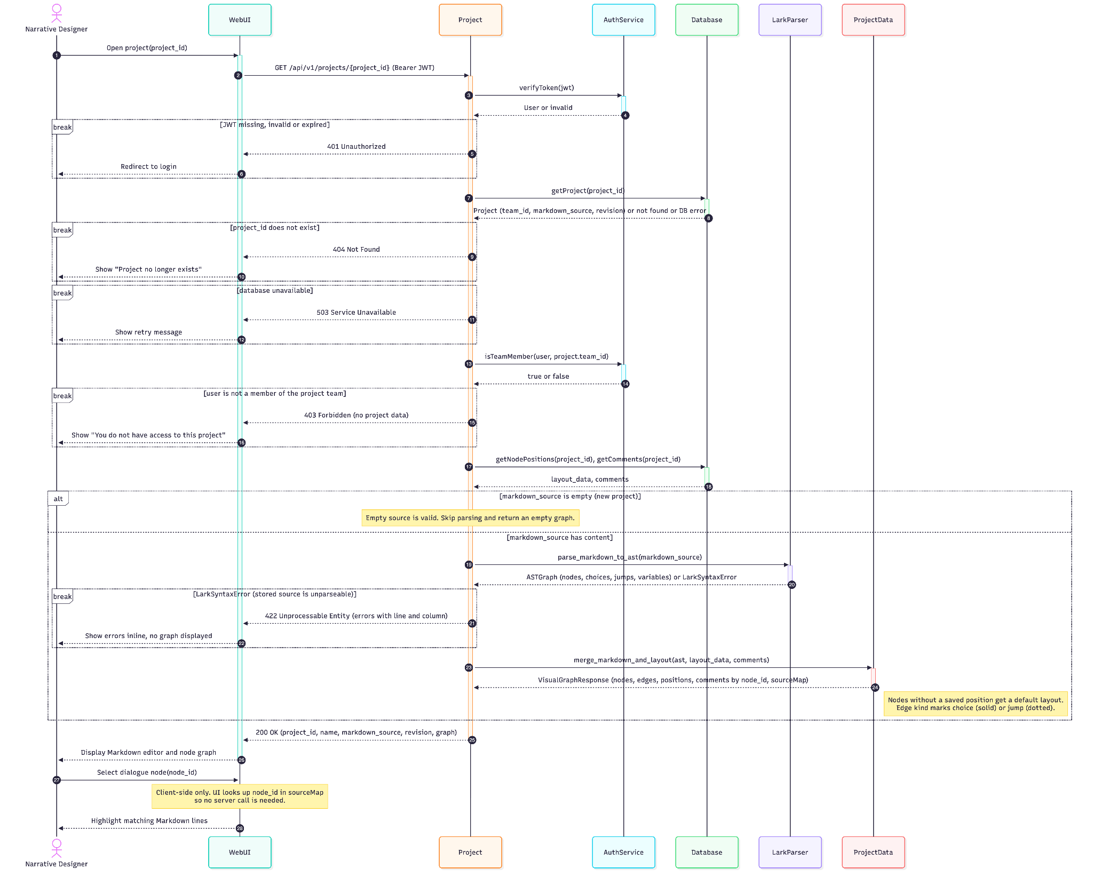
Purpose: The Narrative Designer opens a saved project, and the system shows the node graph, or explains exactly what’s wrong with the Markdown.

Participants: Narrative Designer (actor), WebUI (browser), Project(coordinator), AuthService, ProjectRepository, MarkdownParser, GraphBuilder, JsonCompiler.

Happy path:

- The user opens a project, and the UI sends GET /api/v1/projects/{projectId} with their token.
- Project Service asks Auth Service whether this user may read this project. Auth Service answers valid, expired, or denied.
- Project Service asks the repository for the project and gets back the Markdown and its version.
- Project Service sends the Markdown to MarkdownParser, which returns nodes, choices, jumps, and any errors with line and column.
- With no errors, GraphBuilder turns the parse result into graph nodes, edges, and a sourceMap from each node ID to its Markdown lines.
- Json Compiler produces the JSON AST.
- Project Service returns 200 with graph, JSON, and source map, and the UI displays the graph.
- When the user clicks a node, the UI looks up the node ID in the sourceMap and highlights the Markdown lines. No server call is needed, which is why the diagram shows only a note there.

Failure paths:

- 401: the token is expired or invalid, so the user goes to the login page. (US-31)
- 403: the user is logged in but isn’t on the project’s team, so they see an access-denied message.
- 404: the project doesn’t exist. (US-37)
- 503: the database is down, so they see a retry message.
- 422: The Markdown has errors (syntax errors, duplicate node IDs, or jumps to missing nodes). The UI shows the errors inline and produces no graph or JSON. This matches the US-01 acceptance criterion.

5.2 Sequence Diagram:
Flow 2: JSON Export and Validation
Purpose: The narrative designer exports the final JSON file to be used as input for the game engine. Either the Project Service produces a valid file or lists out the errors with it.
Project Link+Image:
Flow 2 Link
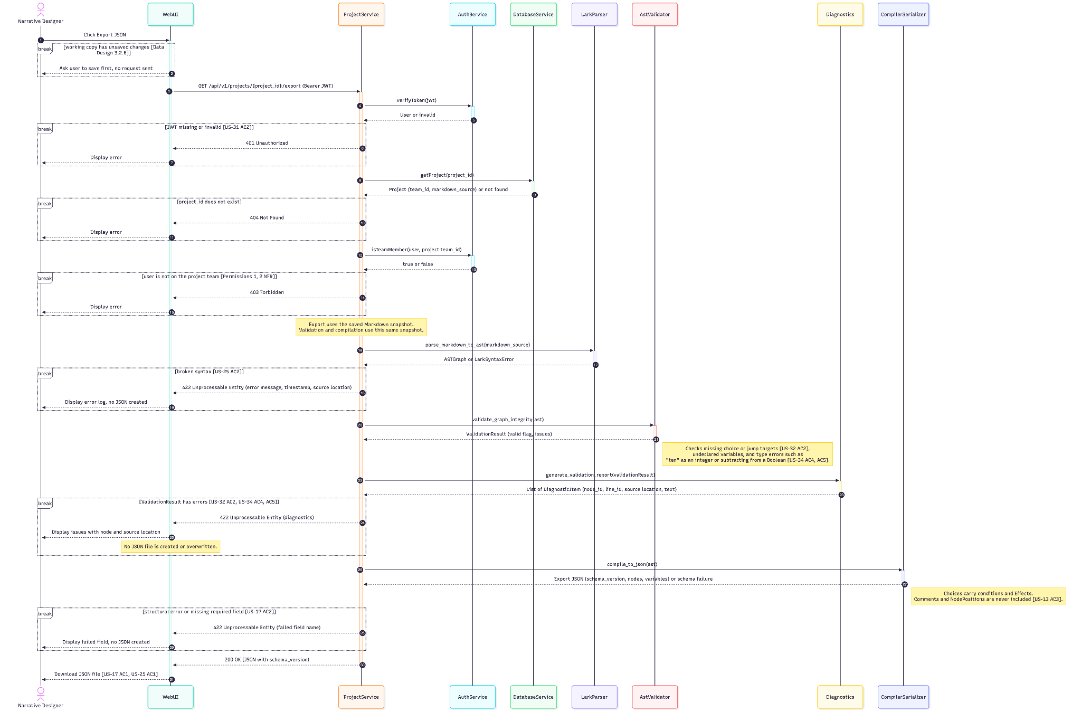
Happy Path:
- User clicks on export JSON
- UI sends GET /api/v1/projects/{project_id}/export with the JWT
- ProjectService verifies the token, loads the project, and confirms the user is on the project’s team.
- Lark Parser parses the saved Markdown into an AST. Validation and compilation both use this same saved snapshot, so the JSON matches what’s stored.
- Validation Tool(AST Validator) validates the AST. It verifies each choice and jumps into an existing node, checks if all variables are declared.
- Compiler Serializer builds the JSON. Comments and node positions are left out(US-13). It also checks the structure against the schema(US-17)
- Project Service returns 200 and the file is downloaded.(AC1 of US-17, AC1 of US-25)
Failure Paths:
In case of a failure, no JSON is created
- 401: the token is missing or invalid (US-31 AC2).
- 404: the project doesn’t exist.
- 403: the user isn’t on the project’s team (Permissions NFRs).
- Broken Syntax, 422(AC2 of US-25): Parser can’t read the Markdown
- Validation errors, 422(AC2,AC4,AC5 of US-34):
  - A jump targets a missing node(AC2)
  - A variable has the wrong type(AC4)
  - A choice subtracts from a boolean (AC5)
- Structural Error, 422(AC2 of US-17): JSON fails schema validation.

5.3 Activity Diagram

Activity Diagram:
User Story: US-36
Describes the undo and delete functionality of the Project Service

Project Link+Image:
Activity Diagram
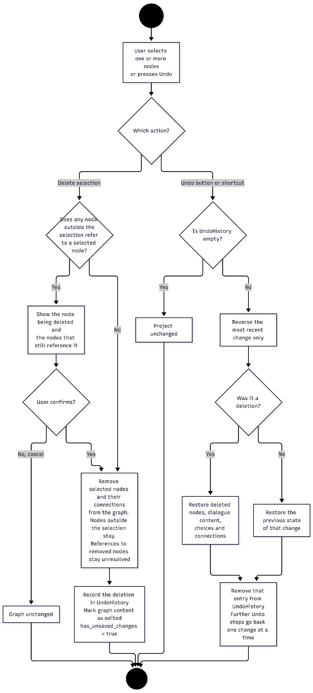
5.4 State Machine
State Machine: Tracks whether the Markdown and node graph represent the same source dialogue
Project Image+Link:
State Machine Link
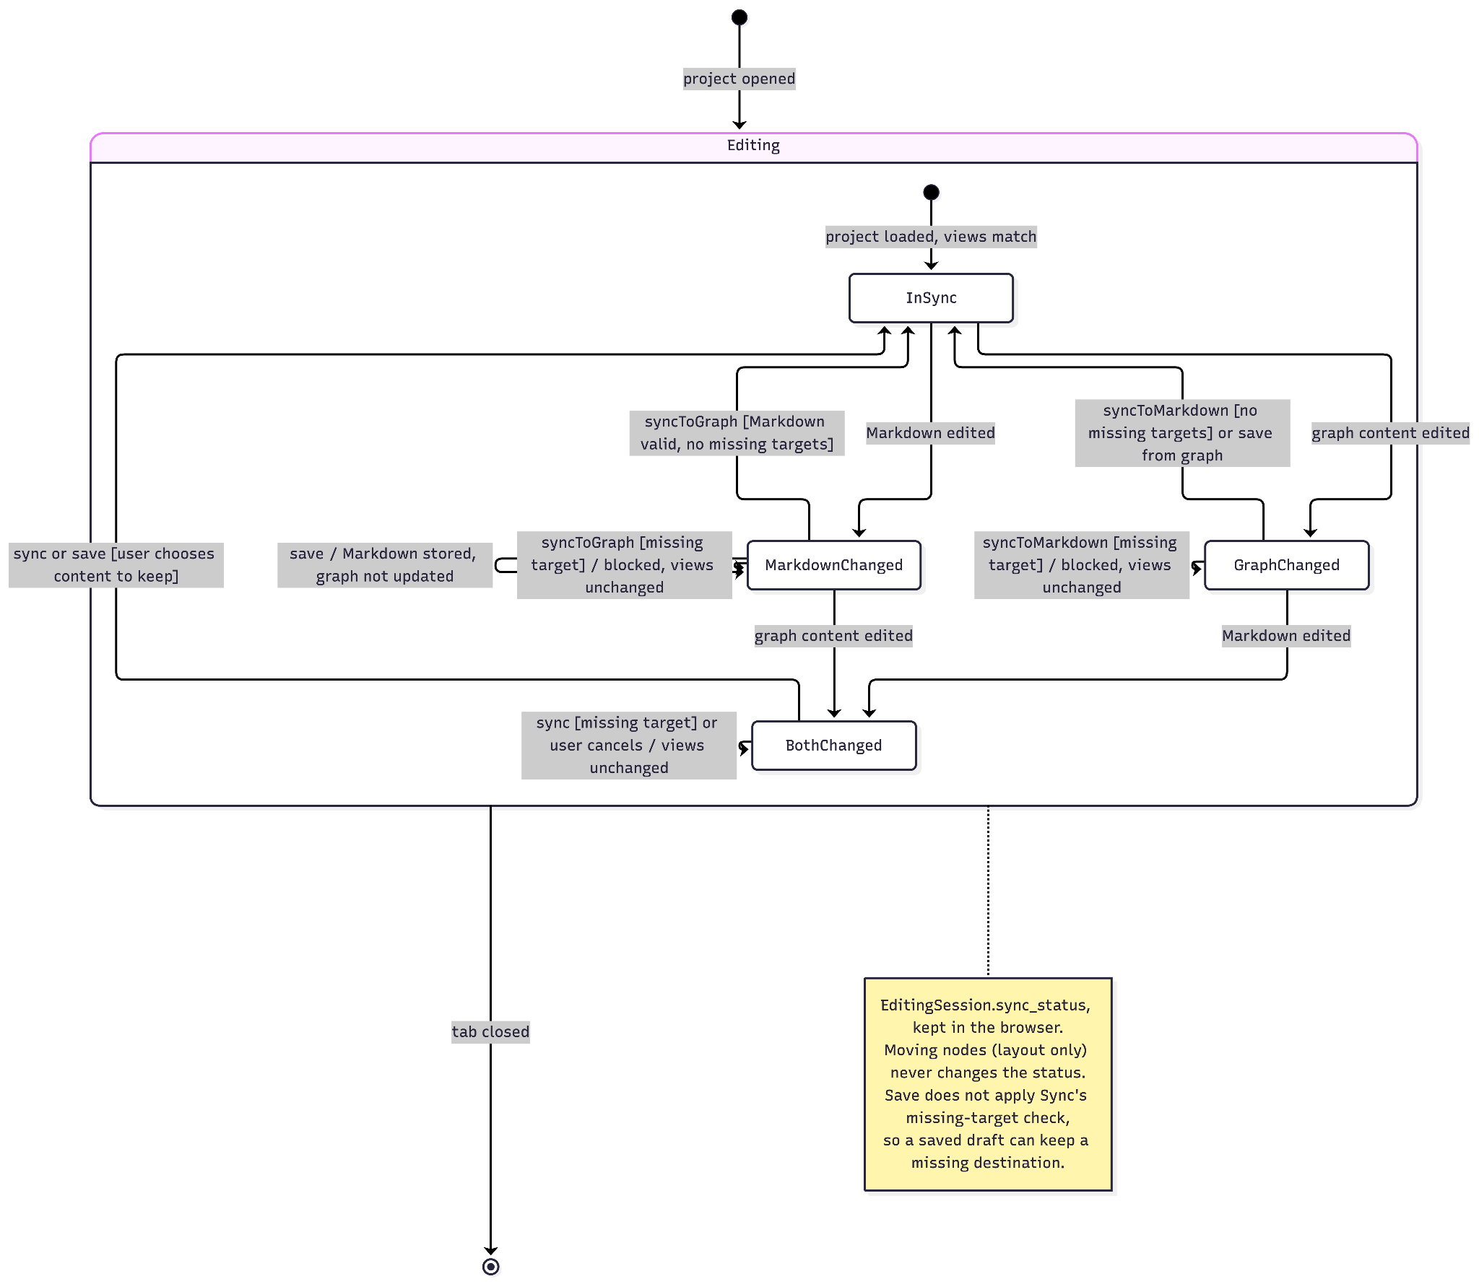
Mapped to US-35’s Acceptance Criteria:
AC1 and AC2- Graph to Markdown Sync
AC3 and AC4- Warn and confirm cases in case of edits for the Markdown
AC3, AC5 and AC6- A self loop to indicate that if you click on a sync button but nothing was synced then the status remains the same

6 Design Decisions
Reviewer: Aryan Navin
Data Design decision records:
- Authoritative dialogue content:
- Context: The tool supports manual editing and synchronization between Markdown and a Node graph, then exports corresponding JSON. Our meeting on October 14 established Markdown as the dialogue source of ‘truth’. Saving an independently editable graph alongside it would require rules for reconciling two versions of the same narrative.
- Options considered:
- save Markdown as the dialogue source, with separate positions and comments. Parse Node, DialogueLine, Choice, Jump, Variable, and Effect objects from a particular source snapshot for the editor and export. Reconcile graph edits with that source before persisting them.
- save structured Node/Choice/Jump/Variable/Effect records as the dialogue source and generate Markdown from them. Store enough ordering and source-format information to support Markdown editing and the required round trip.
- Decisions(Proposed): Use Option A. A successful save persists one authoritative Markdown source and the agreed position data. Rebuild dialogue objects rather than maintaining a second database copy of the same narrative. Save keeps the Markdown when it has syntax errors, but export JSON is generated only after validation. Use one source per Project. Save from the graph converts its pending edits to Markdown using the same conversion and conflict rules as manual Sync. Export uses the saved Markdown source.
- Consequences: This reduces duplicate-content synchronization in the database, but requires a parser and a serializer that preserve dialogue order, Choices, Jumps, Variable definitions, and Effects. Variable references must retain name and scope. Comment and position references to parsed Nodes cannot use a Node database FK, so identity, rename, and deletion rules need application-level handling. Rebuilding derived objects adds parsing work to Open and Export, which must fit the Sprint 1 performance requirements. Source spans must be rebuilt after source changes. Node deletion must also coordinate independent Comment records and saved positions. Because Save accepts Markdown that does not parse or has duplicate Node IDs, Open shows such a draft as text with its diagnostics. These Saves leave stored positions and Comments unchanged. This relaxes the Sprint 1 Data Integrity rule against saving invalid syntax
- Stale-save detection and atomic project writes:
- Context: US-31 AC3 requires 409 for an outdated save. The Data Integrity NFR requires all partial updates to roll back. The story uses version ID while the NFR mentions version timestamp; the token representation is not settled. Any feasible option must reject stale writes rather than overwrite newer content.
- Options considered:
- an integer revision for the save unit. The request carries its loaded revision. A conditional database update matches the current revision and increments it once in the same transaction as positions and the new commit reference.
- a database-issued version timestamp for the agreed save unit. The request carries that timestamp. An equivalent conditional update rejects mismatches, with a guarantee that every successful write produces a distinguishable token. Timestamp precision and token generation must be specified.
- Decisions(Proposed): Use Option A at Project level. Django locks the Project row and checks the expected revision before writing to GitHub, so a stale request returns 409 and creates no commit. After the GitHub commit, positions, the incremented revision, and head_commit_sha commit together. Comments are saved independently without changing Project.revision. The export schema_version identifies the JSON format, while head_commit_sha identifies the saved Markdown version.
- Consequences: Users may need to refresh and reapply changes after a conflict; this proposal does not include automatic merge. The client must retain its base_revision. A Project-wide token is simple, but edits to unrelated parts of one Project can still conflict. Excluding Comment writes from that token avoids conflicts caused only by review notes, while requiring separate handling of Comments during node deletion. Holding the lock during the GitHub call makes concurrent Saves of one Project wait for each other. A database failure after the GitHub commit leaves an unused commit in the repository history.
- Markdown and project data storage:
- Context: Our meeting on October 14 placed Markdown in GitHub and other project data in Neon Postgres. Each Save would produce a commit so the team could trace earlier versions. Splitting a Save across GitHub and Postgres introduces a failure window: one write can succeed while the other fails. Django database transactions do not include GitHub commits. Postgres stores Markdown in a text column and JSON in json or jsonb, so neither format requires a separate NoSQL database. Wiki.js 2.x provides a useful storage reference: it keeps content in its database and synchronizes Git separately on a schedule.
- Options considered:
- GitHub holds the current source; Postgres holds project metadata. One Save then writes to two systems that cannot share a transaction, so a failure can leave them out of step.
- Postgres holds current data and source snapshots; GitHub receives every saved version asynchronously. Save stays in one transaction, but the team needs a background task and a pending status.
- Postgres holds current data; GitHub periodically receives only the latest source. This is simpler, but saves made between pushes never reach the history.
- A document database holds Markdown and nested dialogue objects. It adds a second database beside the relational user, team, and revision data.
- Decisions: Use Option A. It keeps Markdown and its history out of Postgres and needs no background task. Store each Project's Markdown as projects/<project_id>.md in one private GitHub repository and record the current commit in Project.head_commit_sha. A Save commits the Markdown first, then writes positions, revision, and head_commit_sha in one database transaction, so Postgres decides which commit is current. Repository writes run one at a time. Changes made directly in the repository are not imported.
- Consequences: Postgres stores no Markdown or saved snapshots, and no background task or publication status is needed. Opening, exporting, and any Save that changes the Markdown depend on GitHub: they fail while GitHub is unavailable, and the GitHub call counts toward the ten-second open time. A database failure after a GitHub commit leaves an unused commit in the history. Saves to the shared repository wait for each other. The Git history contains only Markdown, so an older commit does not restore positions or Comments. Option B remains the fallback if GitHub storage causes problems during implementation.

Interface Design Decision Records

API Interface Granularity:
- Context: We need communication between the React Flow visual canvas and Markdown text in the browser and the Django backend server. When a user modifies nodes and connections, those changes need to be saved. There are two ways of managing this communication: either to have fine-grained REST endpoints for individual entity operations or coarse-grained payload endpoints that receive the entire markdown_source and layout_data.
- Options considered:
- Fine-Grained REST Entity Endpoints
  - Expose CRUD endpoints for each entity in the system
  - POST /projects/{id}/nodes
  - PUT /projects/{id}/nodes/{node_id}
  - DELETE /projects/{id}/nodes/{node_id}
  - POST /projects/{id}/choices
  - PUT /projects/{id}/choices/{choice_id}
  - Pros:
    - Lightweight payloads.
    - Reduced database write overhead for minor visual changes.
  - Cons:
    - Our Lark compiler needs the entire Markdown file to build and validate the AST. Partial updates can’t be parsed.
    - Edits on multiple nodes would fire dozens of HTTP requests.
- Coarse-Grained Payload Endpoints
  - Expose high-level endpoints that take in the complete Markdown file and layout data in a single request.
  - PUT /api/v1/projects/{project_id}/save
  - POST /api/v1/projects/{project_id}/sync
  - Pros:
    - Backend Lark parser and validator modules can execute while saving and syncing.
    - Guarantees the visual graph and Markdown file are synchronized in the database.
    - Only one REST request is enough. Eliminates network race conditions.
  - Cons:
    - The size of the payload can be big. And it would increase as the project grows larger.
    - When HTTP 409 Conflict happens due to two people editing and saving at the same time, one team member needs to discard all their changes, instead of merging individual node edits.
- Decisions(Proposed): Use Option B, Coarse-Grained Payload Endpoints. Although we need to face a much larger payload, we don’t have to save and sync constantly. We give users buttons to save and sync manually so that each time they update the project, they understand that it will take some time. This also helps them to have a validated AST whenever they try to save or sync. It also keeps files in the database synchronized and ready for other team members.
- Consequences: CPU usage on the backend would increase because each time we save or sync, we are parsing the entire Markdown file again. Team members with an old revision number would lose a lot of progress if they didn’t fetch the newest progress on time. Payload size might cause unexpectedly long waiting times for parsing.

Modeling Choices

Modeling Sync and Undo Behaviors
- Context: We had to model the bidirectional sync (US-35) and the delete/undo functionality (US-36). We needed to decide which UML behavioral diagrams best represented these distinct processes for our developers.
- Options considered:
  - a. Use Activity Diagrams for both features to map out the step-by-step user UI interactions, system checks, and logical paths.
  - b. Use a State Machine to track the data states for the Sync Workflow, and an Activity Diagram for the sequential Delete/Undo logic.
- Decisions(Proposed): We chose option B. We used a State Machine for US-35 because the synchronization process is about tracking the divergent states of the Markdown and Graph Over time (so the InSync, MarkdownChanged, etc.). We used an Activity Diagram for US-35 because deleting and undoing are procedural actions with explicit branching decision points (e.g., checking if the undo stack is empty or prompting user confirmation).
- Consequences: Using two different behavioral diagram types means our developers have to read different formats depending on the feature they are building. But it gives us a more accurate technical view. We get proper state transitions for data alignment and procedural flowcharts for step by step actions.

7 Traceability
Author: Aryan Navin
Reviewer: Leyan Huang
MVP Traceability

MVP Story ID | Components | Interfaces/Endpoints | Diagrams
US-35: Bidirectional Sync | Browser, Django, Lark Parser | - Sync (POST)  - Markdown To Graph  - Graph To Markdown | - State Machine(sync_status)  - State Machine (sync_status)  - DD-1  - DD-3
US-31: User login/access | Browser, Django, Postgres | - User Login (POST)  - Fetch Project (GET) | - Flow 1 (Load/Parse)  - DD-2
US-37: Start, load, save | Browser, Django, Postgres, GitHub API | - Create Project (POST)  - Fetch Project (GET)  - Delete Project (DELETE)  - Save Visual Canvas (PUT) | - Flow 1 (Load/Parse)  - DD-2  - DD-3
US-01: End-to-end visualization | Browser, Django, Lark Parser, Postgres | - Fetch Project (GET)  - Sync (POST)  - Export compiled JSON (GET)  - Markdown To Graph | - Flow 1 (Load/Parse)  - Flow 2 (Export)  - Activity (Graph ↔ Markdown Sync)  - DD-1  - DD-4
US-32: Conditional Logic | Browser, Django, Lark Parser, Postgres | - Save Visual Canvas (PUT)  - AST Validator | - Flow 2 (Export)  - DD-1  - DD-4
US-29: Visualizing connections | Browser, Django, Postgres | - Save Visual Canvas (PUT)  - Merge Project | - Flow 1 (Load/Parse)  - DD-1
US-36: Deleting/undo nodes | Browser, Django, Postgres | - Save Visual Canvas (PUT)  - Sync (POST) | - Activity Diagram  - DD-3
US-12: Add a New Node | Browser, Django, Postgres | - Save Visual Canvas (PUT)  - AST Validator | - DD-1  - DD-3
US-20: Undo button | Browser | Client-Side Session Logic | DD-3
US-13: Node comments | Browser, Django, Postgres | - Fetch Project (GET)  - Create Node Comment (POST)  - Update Node Comment  - Delete Node Comment (DELETE) | DD-2
US-02: Node connections check | Django, Lark Parser | AST Validator | DD-4
US-34: Export variables/effects | Django, Lark Parser | - Export Compiled JSON (GET)  - JSON Compiler | - Flow 2 (Export)  - DD-1  - DD-4
US-17: JSON version validation | Django, Lark Parser | - Export Compiled JSON (GET)  - JSON Compiler | - Flow 2 (Export)  - DD-4
US-25: Export JSON AST | Django, Lark Parser | - Export Compiled JSON (GET)  - JSON Compiler | - Flow 2 (Export)  - DD-4

NFR Traceability

NFR Category & Rule | Design Mechanism | Verification Model
Performance 1: Open project in less than 10 seconds | The Fetch Project endpoint reads Markdown from Github, parses it, and combines it with saved NodePositions from Postgres (as specified in Data Design 3.3.2). | Measure the time from clicking Open on a saved project in Chrome until the graph is fully displayed and usable.
Performance 2: Export JSON in less than 10 seconds | The Export Compiled JSON endpoint executes a single pass of the Lark parser and compiler on the backend. | Measure the time from clicking Export in Chrome on a valid project until the JSON file finishes downloading.
Data Integrity 1: No invalid syntax | The Save Visual Canvas endpoint allows saving drafts with syntax errors alongside diagnostics. Invalid syntax is rejected strictly during Sync and Export operations. | Attempt to save a draft with invalid syntax and reopens with diagnostics. Then, verify the backend correctly rejects invalid syntax when attempting to Sync or Export.
Data Integrity 2: Reject outdated writes | The Save Visual Canvas endpoint requires an integer base_revision. Django executes a conditional Postgres update that rolls back if the revision does not match. | Have two users attempt to save the same scene with the same integer base_revision, and verify the backend checks the revision and rejects the second request with a 409.
Security 1: HTTPS only | Production deployment configuration ensures the client and server only communicate over encrypted channels. | Verify all saving/website requests use HTTPS and that any HTTP requests redirect to HTTPS.
Security 2: Authenticated users only | Django REST API endpoints require a valid JWT token via the Authorization header. | Send open/save/export/delete requests logged out or lacking permissions, and verify the server returns a 401 or 403 without exposing data.
Security 3: No execution of malicious code | The parser treats markdown strictly as text, and the React frontend escapes outputs instead of injecting HTML. | Save HTML/Python/JavaScript inside a project node and verify it displays as raw text rather than executing upon project open.
Permissions 1: Non-members receive 403 | Django backend verifies the user’s team ID matches the project’s TeamMembership table before processing API requests. | Log in as a user from Team X and call the endpoints on a Team Y project, and verify all four return 403 with no project data.
Permissions 2: API server-side enforcement | Authorization checks are placed directly in the Django API endpoint views, completely independent of the UI logic. | Use an API client like Postman (no browser) to attempt cross-team requests, and verify the server denies access identically.

8 Sprint 1 revisions
Author: Jay Stadelman
Reviewer: Shutong Ji and Swarna Sweth
Feedback: (3 items in bold text)
- Points off for MVP size and a few messy merges.
Reviewed all MVP stories. Several that were merged and “rejected” but the story did not get marked out. To remove ambiguities (for MVP stories only), rejected stories have had their ids crossed out and “rejected” has been highlighted in red and "accepted” has been highlighted in green. In our section 2.2 Order by Priority there was a mistake which left only 12 numbered bullets but 13 listed items. It has been fixed. When addressing additional feedback we added an additional MVP user story bringing our total accepted user stories to:
- 14 accepted MVP stories
- 8 accepted Stretch stories
- 3 accepted out of scope stories
- There are well over the expected 10–20 MVP stories
It is our mistake that it was hard to clearly see our MVP stories. The table was hard to read and manage which is why we added section 2.2 Order by Priority. We had the correct approved stories listed which was 13 but there was an error with one of our line breaks leading to 12 numbered bullets. This has been rectified.
- the conversation start node was incorrectly merged into the delete/undo story.
The error is this: US-36 (Merged US-12, US-14): Deleting unwanted nodes and branches, including multiple selections, and undoing changes

We have corrected this error by reinstating US-12 and redesigning it to be a stand alone MVP US. US-36 is still the redesign of US-14. This added an extra US giving us 14.

Sprint 2 Backlog and Effort

Task | Owner | Initial estimate (h)(Ideal Time) | Hours spent(Elapsed Time) | Velocity
Architecture overview | Jay Stadelman | 2h | 2h | 1
Modeling choices | Aryan Navin | 5h | 2h | 2.5
Data design | Leyan Huang | 8h | 8h | 1
Interface design | Shutong Ji | 8h | 7h | 1.14
Key behaviors | Swarna Sweth | 4h | 3.5 | 1.14
Tracebility | Aryan Navin | 4h | 3h | 1.34
Sprint 1 revisions | Jay S | 1h | 1.5h | 0.67
Design and discussion log | Swarna and Leyan | 1h | 0.5 | 2
Total |  | 33h | 27.5h | 1.2

Total Sprint Velocity= Ideal Time/Elapsed Time=33/27.5=1.2

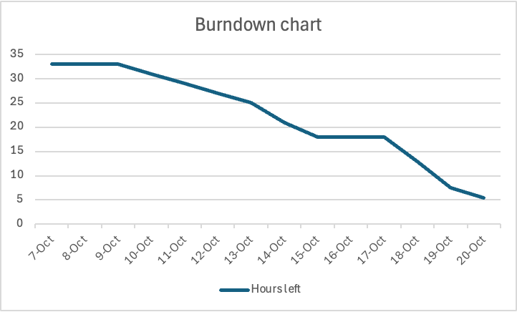

9 Meeting Notes and Design discussion log
Date | Attendees | Topic & Alternatives Debated | Decisions Made & Resolution | Open Issues / Disagreements
10/08/2026 | Shutong, Swarna, Jay, Aryan  Leyan was available via Slack due to his midterms | • Sprint 2 scope & workload splitting for design sections.  • Used Planning Poker to vote on task effort.  • Debated whether to build the burn-down chart now vs. during the next call. | • Section Ownership Assigned:  – Jay: Architecture & Sprint 1 Revisions  – Aryan: UML Choices & Traceability  – Leyan: Data Design  – Shutong: Interface Design & Design Decisions  – Swarna: Key Behaviors  – Swarna and Leyan: Design Discussion Log  • Postponed burn-down chart to next call.  • Agreed to log hours per task to calculate velocity. | • Clarification needed on how to define "introduce baseline for the project."
10/14/2026 | Shutong, Swarna, Jay, Aryan, Leyan | • Architecture & Storage:  – Option A (Chosen): Dual storage (GitHub API for Markdown commits + Neon Postgres for metadata/JSON export).  – Option B: Store everything in Neon Postgres.  • Debate: the team considered keeping all data in Postgres but had questions about how to store the Markdown and graph data; GitHub was proposed for its commit history.  • Sync Mechanism: Debated auto-sync vs. manual sync button.  • Deployment: AWS vs. Vercel for front-end.  • Story Pointing: Adopting 0–3 relative scale for user stories. | • Selected Option A (dual storage); Markdown is single source of truth.  • Saving in Node GUI updates Markdown; Markdown changes reach Node GUI only via manual "Sync" button.  • Decision records to be written by respective section owners.  • Assigned peer reviewers for all tasks; target draft completion by weekend due to recent exams. | • Choice of front-end hosting (AWS vs. Vercel).
10/18/2026 | Shutong, Swarna, Jay, Aryan, Leyan | •Section-by-section review of drafted diagrams.  • Addressed instructor feedback on Sprint 1 user stories (specifically US-34).  • Storage: (a) Markdown, positions, and revision in Postgres with GitHub as background history, vs. (b) Markdown in GitHub and other project data in Postgres. • Whether a project with errors can be saved. • Name for the backend service that coordinates project operations. • Sprint 1 feedback on US-12 being merged into US-36. | • Corrected description for US-34 based on Sprint 1 feedback.  • Authors must add summary descriptions to Section 2.  • Story points added to user story tables; velocity calculation scheduled after review completion.  • Chose (b): Markdown stays in GitHub for less database storage and simpler technology; (a) is kept in the decision record as the fallback. • Projects with errors such as missing destinations can be saved. • All sections use "Project Services". • US-12 reinstated as a standalone MVP story for creating nodes (14 MVP stories). | None.
10/19/2026 | Shutong, Swarna, Jay, Aryan, Leyan | • Key Behaviors: Evaluated diagram count and coverage for top MVP flows.  • Section Numbering: Confusing sub-numbering scheme (6.3, 6.4, 6.7) following main sections. | • Swarna to add Activity Diagram; add sequence/activity diagrams for main MVP paths.  • Removed confusing sub-section numbers (6.3, 6.4, 6.7).  • Authors cross-review Sections 3–6 for naming consistency.  • Final Submission Schedule (10/20):  – Reviews due by 12:00 PM.  – Revisions due by 5:00 PM.  – Final team meeting at 8:00 PM to submit. | None

Detailed meeting notes

10/08/2026
- Attended: Shutong, Swarna, Jay, Aryan
- Discussing and going over the Sprint 2 requirements
  - Talked about thinking of overtime and scope
  - Discussed splitting up work for the ‘views’ part of the sprint
  - Used pointing pokers to vote and decide who would take what task
    - Might have to put multiple people onto a section since some are a lot of work
    - Jay said he can take architecture view
    - Aryan said he can take UML section
    - Leyan takes the Data design section
    - Shutong said he can take the interface design section
    - Swarna said she can take key behaviors section
- aryan - traceability
- design discussions - shutong
-jay - sprint1 revisions
- swarna and leyan - design discussion log
- mentioned the goal for this sprint is to have a solid idea of what our project will look like, not only on our screen, but the actual workflow and architecture behind the scenes such as database to github to software, etc.
- burn out chart can be possibly done during the next call
- talked about recording how long each of our designated tasks take, so then we can calculate velocity
- Might need to clarify what ‘introduce baseline for the project’ is so the team knows what it is
The sections were assigned as follows:
- Architecture overview - Jay
- Modeling choices (UML decision) - Aryan
- Data design - Leyan
- Interface design - Shutong
- Key behaviors - Swarna
- Design decisions - Shutong (All of us can contribute based on what section we worked on)
- Traceability - Aryan
- Sprint 1 revisions - Jay
- Design discussion log - Swarna and Leyan

10/14/2026
- Attended: Shutong, Swarna, Jay, Aryan, Leyan
- Time and effort analysis, giving an estimate for each task
- Assigned reviewers to all the tasks for this sprint also
- Noticed that everybody was a bit busy due to exams the past week, so we will all try and make an effort to finish all our tasks by the end of this coming weekend, and then hopefully finish reviews and any external plots/charts before next Tuesday
- Story points:
  - Add story points to each user story in our user story table. Add the points in the ID column
  - Scale (Week 5 Sprint Planning slides, Planning Poker): 0, 0.5, 1, 2, 3. With 2-week sprints, 3 is the highest estimate for one story. Points are relative: a 1-point story takes less time than a 3-point story.
- Design decisions:
  - Each member writes the decision records for the section they worked on.
- Architecture overview (Jay presented his draft)
  - Draft: the web application (Markdown editor and node GUI) talks to a Django server over HTTPS. The server handles:
    - authentication and permissions (users, teams, roles, sessions)
    - project services (open, save, delete, export)
    - the parser/converter (Markdown ⇄ node GUI → JSON)
    - GitHub services (Markdown commits)
    - database services (app data)
  - The GitHub API keeps the Markdown commit history in a single private repository. Neon Postgres stores users, teams and roles, project metadata, and the JSON export.
  - Why GitHub: version control. Each save becomes a commit with a timestamp, so the team can trace a user’s saves.
  - Alternative raised: keep everything in Neon Postgres. It is unclear how the Markdown and the graph would be stored in Postgres tables, and a NoSQL database would likely add more complexity than we want.
  - Concern: storing the Markdown in GitHub and the other data in a database may cause problems, and none of us has built this setup before.
  - Sync: saving from the node GUI updates the Markdown. Markdown changes reach the node GUI only when the user clicks the manual Sync button. Markdown is the source of truth at all times.
  - Decision: go with this design for now, and stay flexible if it causes complications during implementation. Jay will expand the section.
  - Open: front-end hosting (AWS and Vercel were mentioned).
10/18/2026
- Attended: Shutong, Swarna, Jay, Aryan, Leyan
- Briefly discussed each section and diagram
- To do: Add summaries to section 2 based on what work you have done
- Corrected the user story description for US-34 based on feedback from Sprint 1
- Add velocity charts after section completion and review
Questions for the Meeting:
What do we call our project service?
10/19/2026
- Attended: Shutong, Swarna, Jay, Aryan, Leyan
- Swarna to add an activity diagram to Key behaviors; more activity and sequence diagrams needed for the top MVPs
- Section 6: removed the 6.3, 6.4 and 6.7 subsection numbers, which followed the section numbers and were confusing
- Sections 3 to 6 are related; keep them cohesive, and everyone does another review pass on their assigned sections
- Authors add story point estimates to their user stories; velocity calculation after reviews
- Reviews done by noon 10/20, authors revise until 5 PM, team meets at 8 PM to finalize and submit
- To Do: Velocity charts, check whether we have achieved our sprint goals, burnout charts

10/20/2026
- Attendees: Shutong, Swarna, Jay, Aryan, Leyan
- Clarified that the document needs at least four decision records in total, including at least one modeling decision and one NFR-driven decision. Not every record needs to address an NFR.
- Reviewed individual ownership of decision records. Agreed to identify each member’s contribution through comments on the relevant record.
- Checked section numbering, spacing, and the author/reviewer labels in Section 6.
- Agreed to keep “Sprint 2 Backlog and Effort” in its current position.

